L E M A

BY AUTHORITY OF THE COMMITTEE OF LOWER EXE MOORING ADMINISTRATION Ltd AND IN ACCORDANCE WITH PART II OF SCHEDULE 1 (NOTICE OF INTENTION TO SELL GOODS) AND SECTION 12 OF THE TORTS ACT 1977

PLEASE NOTE: (to recover LEMA’s out of pocket expenses)

THAT THE BOAT SHOWN IN THE PICTURE BELOW (white hull/blue decked yacht), CURRENTLY MOORED IN SHELLY GUT AND DEEMED ABANDONED WILL BE OFFERED FOR SALE BY TENDER.

WRITTEN TENDERS SHOULD BE SENT TO:

THE ADMINISTRATOR
LOWER EXE MOORING AUTHORITY
PO BOX 230
EXMOUTH EX8 9BQ
TELEPHONE: 07518 902664
E MAIL: lowerexe.moorings@btinternet.com

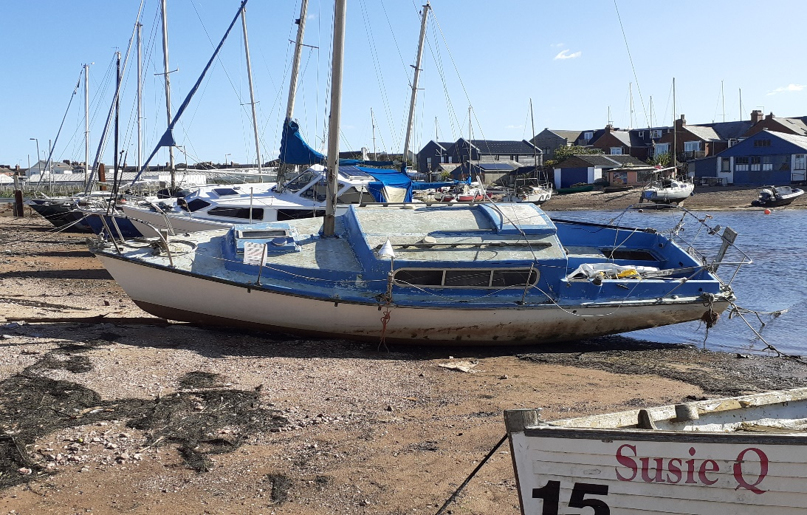

Last Date for Tenders : 31st DECEMBER 2020

(Please note that the successful applicant will be required to remove the boat immediately from the mooring on completion of the sale to him/her – LEMA can give no guarantees as to the seaworthiness of this vessel and it will be sold as seen - the purchaser should rely on his/her own investigations)

